

CLOUD COMPUTING LAB
BSE ( V-B )

Submitted By:
Musfira Farooq
Roll No:
2023-BSE-045
Submitted To:
Sir Muhammad Shoaib

LAB 09

Codespaces + AWS: GH CLI, AWS CLI, EC2, IAM, Security Groups, Filters & Queries

Task 1 — GitHub CLI, Codespace setup and authentication
Objective: Install GH CLI, authenticate for Codespaces, and create/connect to a Codespace.
- Install GitHub CLI
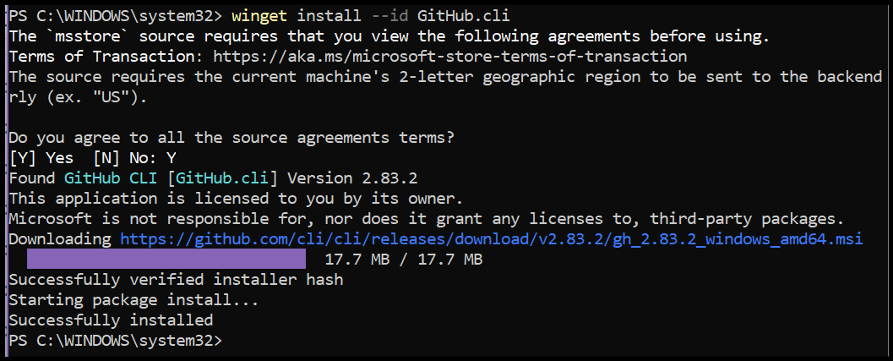
- GH CLI authentication for Codespaces
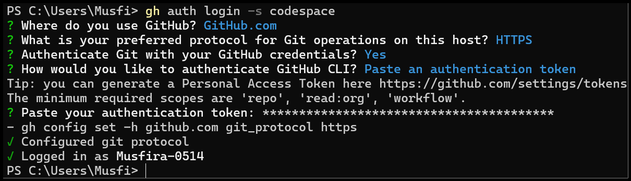
- List available Codespaces
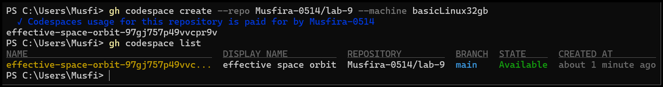
- Connect to Codespace
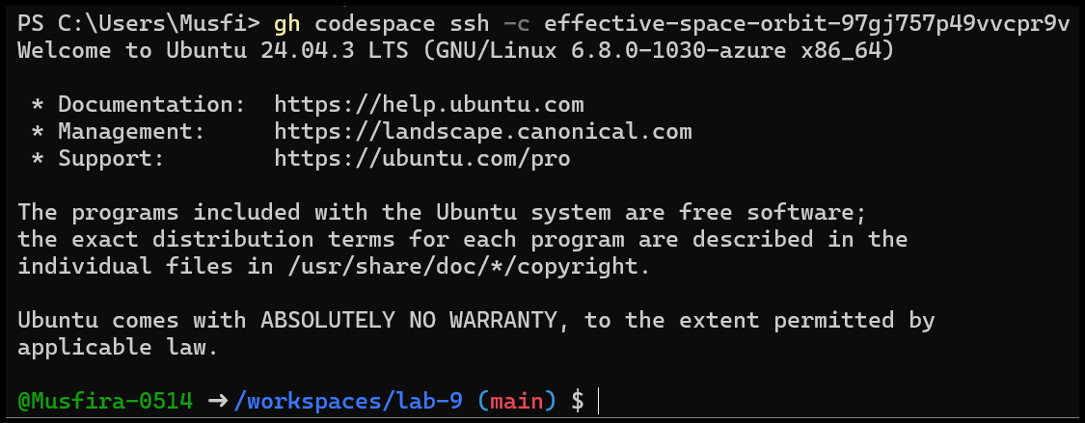
Task 2 — Install AWS CLI inside the Codespace and configure it
Objective: Install AWS CLI, configure it, and verify connectivity.
- AWS CLI install and version check
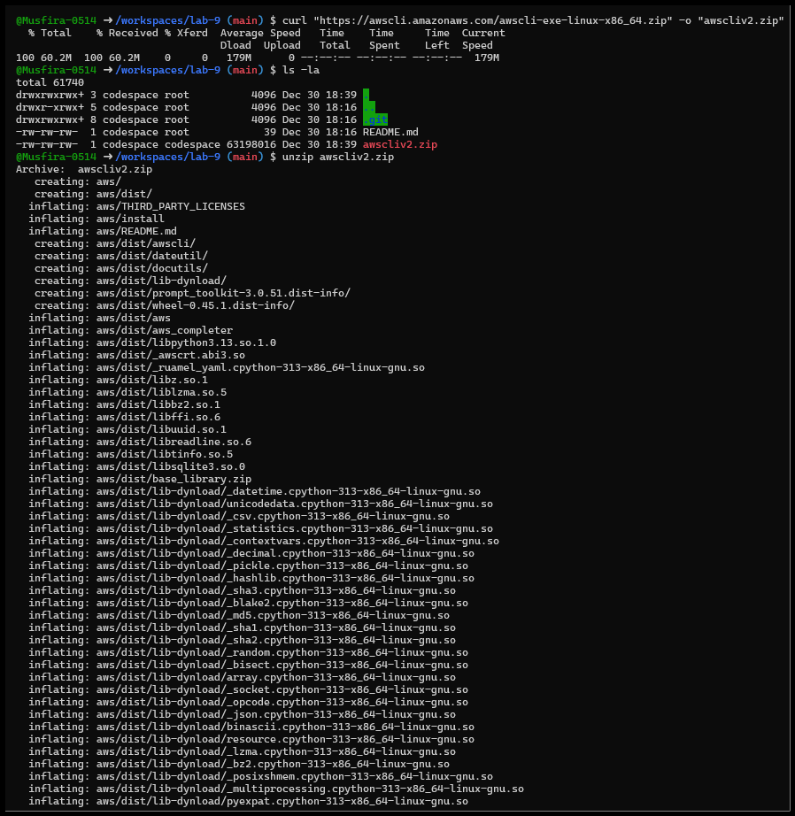
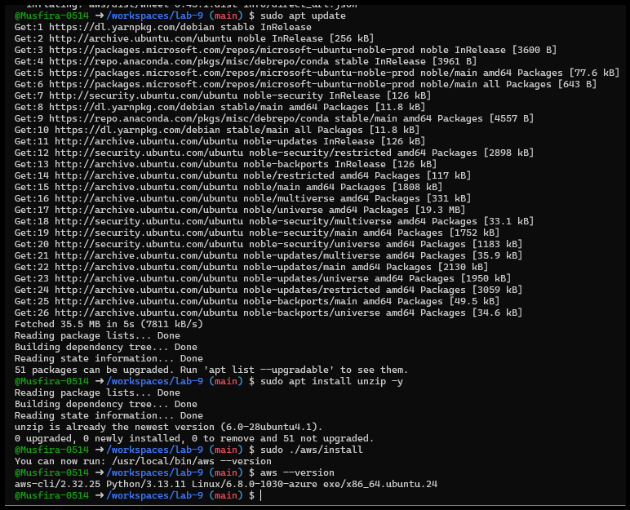
- AWS configure credentials
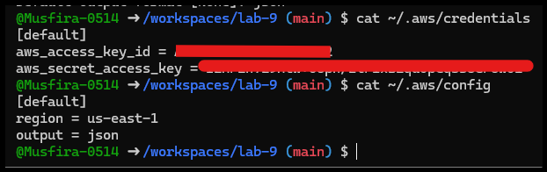
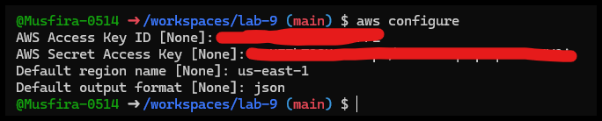
- Verify connectivity (aws sts get-caller-identity)
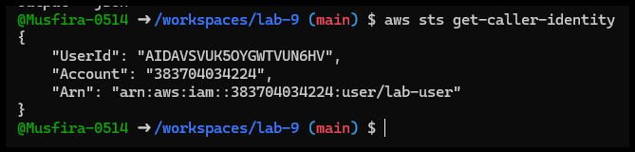
Task 3 — Security group creation & ingress rules
Objective: Create and configure EC2 security group with SSH/HTTP rules.
- Create security group
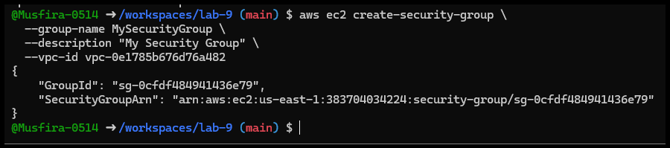
- Describe SG before ingress
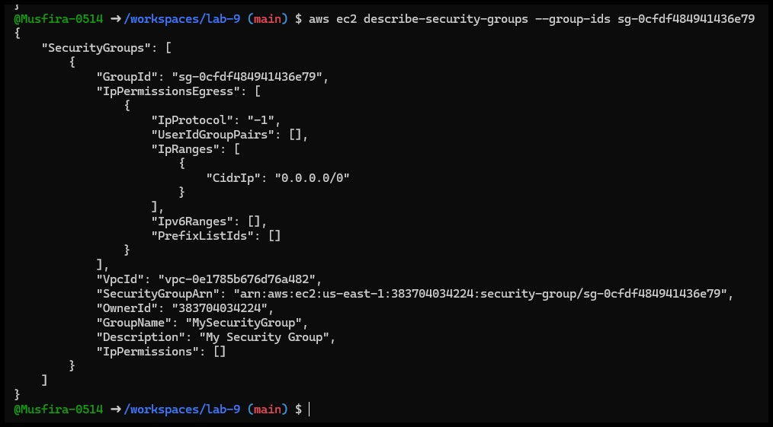
- Codespace public IP
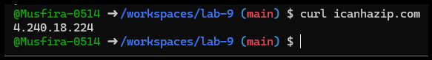
- Authorize SSH & HTTP rules
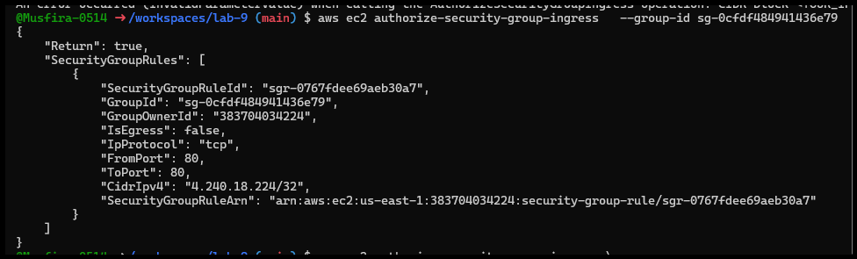
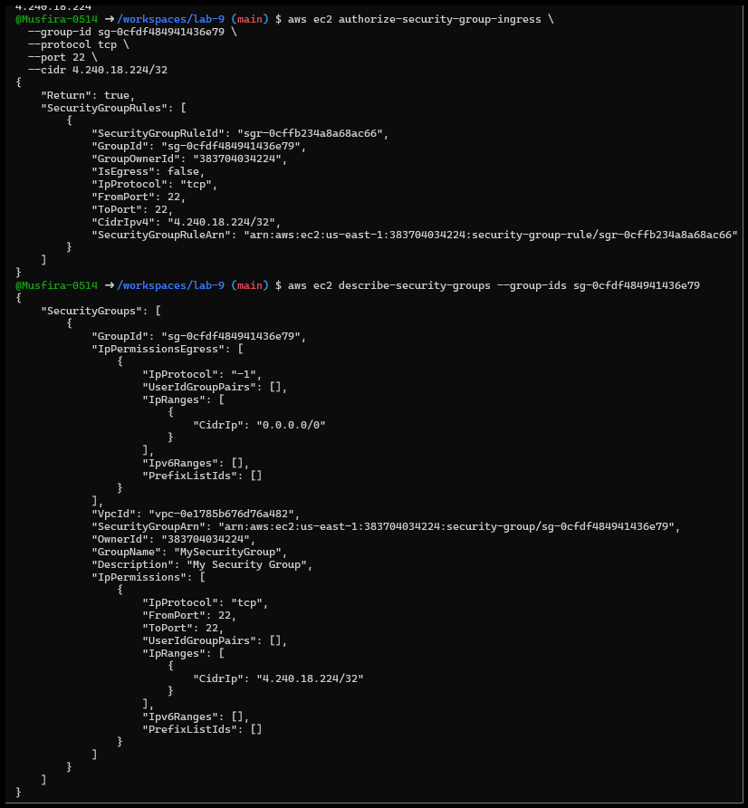
- Final SG verification
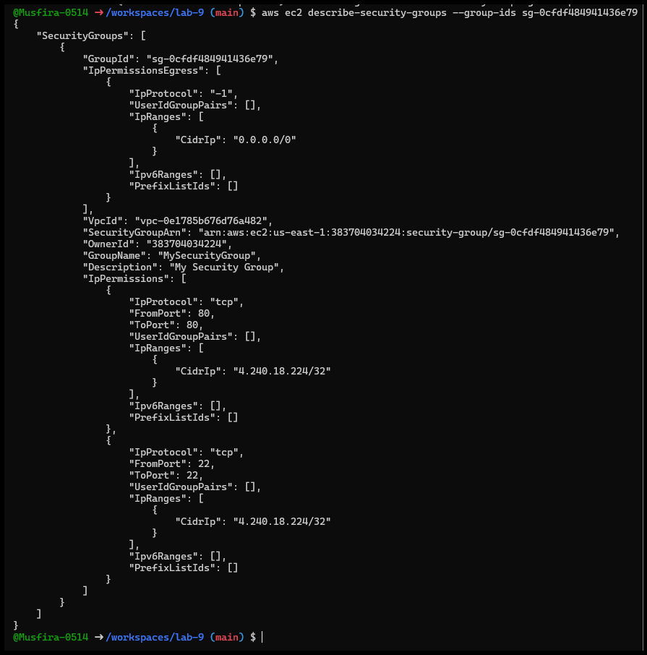
Task 4 — Key pair creation, EC2 launch & SSH
Objective: Create key pair, launch EC2 instance, SSH access, and manage instance state.
- Create key pair
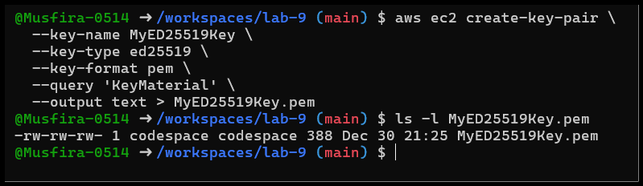
- Describe key pairs
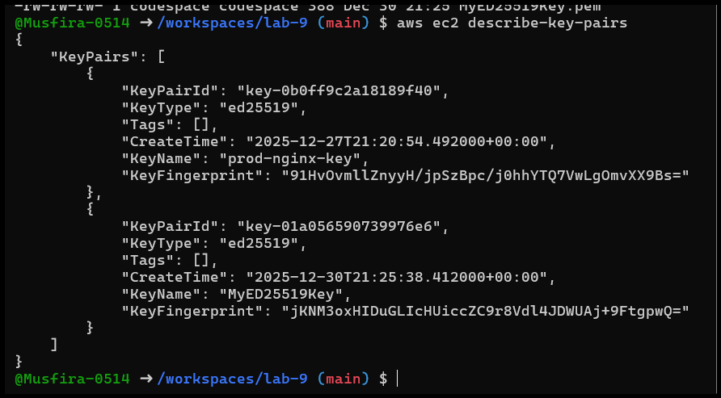
- Delete key pair (optional)
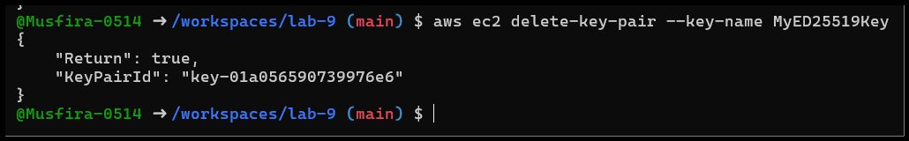
- Launch EC2 instance
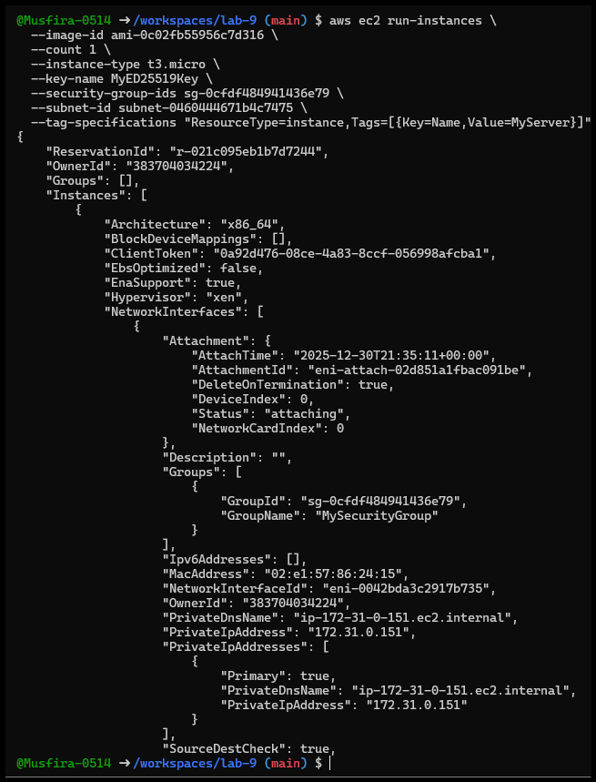
- Describe instance & public IP
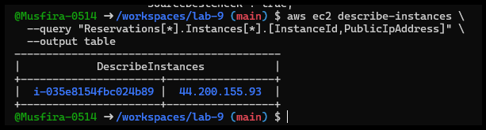
- SSH permission error & fix
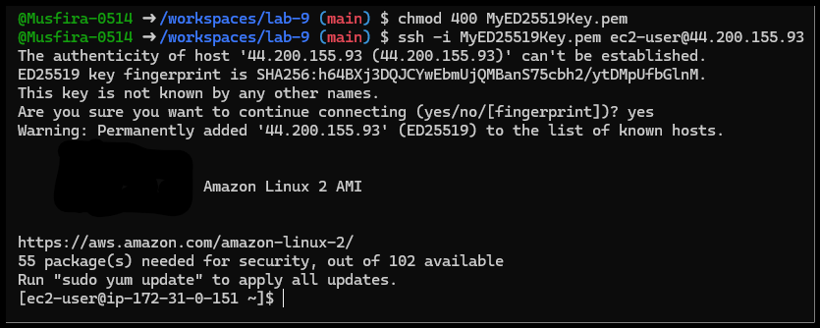
- Stop/Start/Terminate instance

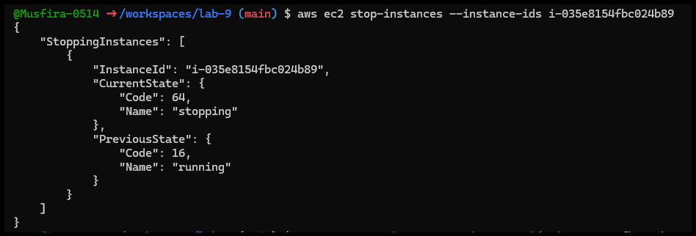
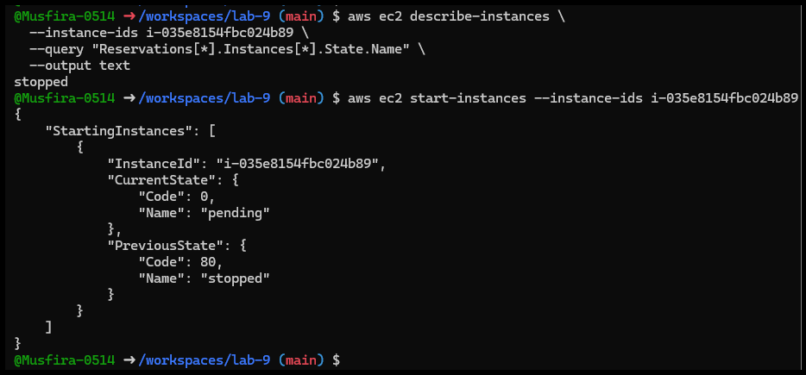
Task 5 — AWS describe- commands
Objective: Inspect AWS resources.
- aws ec2 describe-security-groups
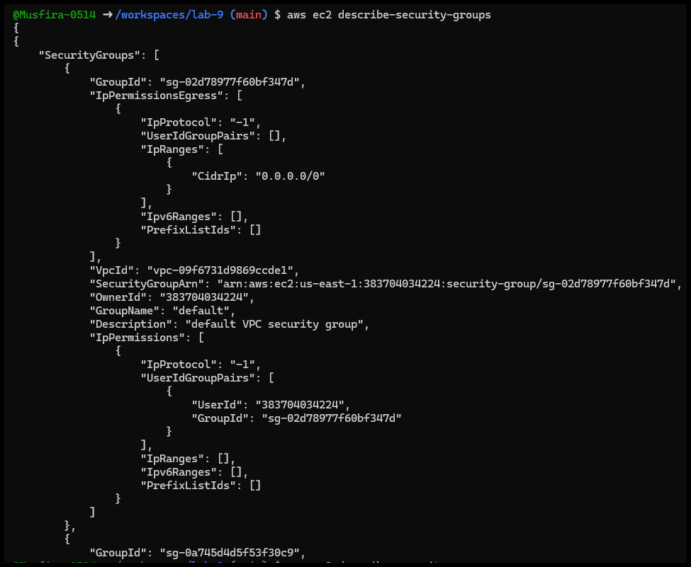
- aws ec2 describe-subnets
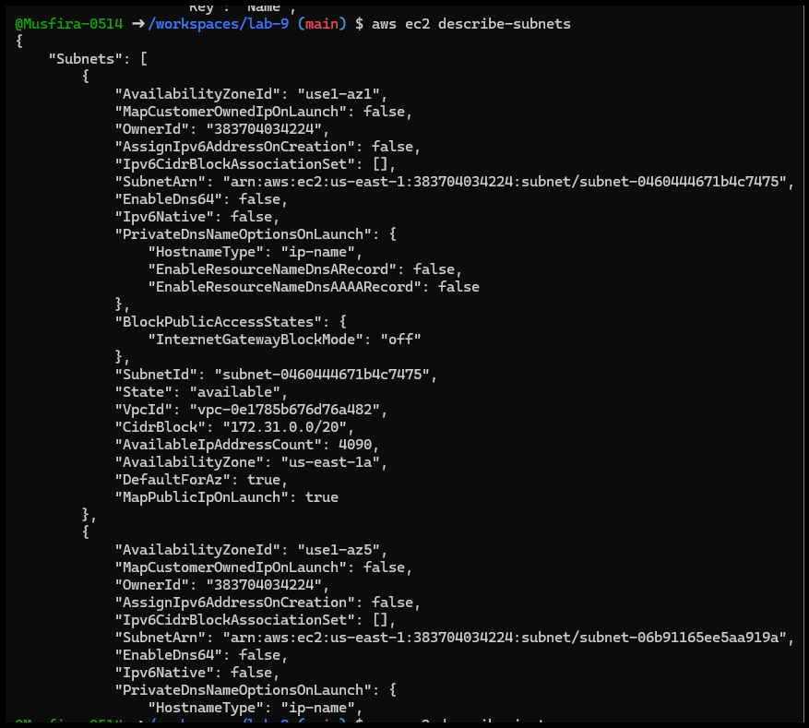
- aws ec2 describe-instances
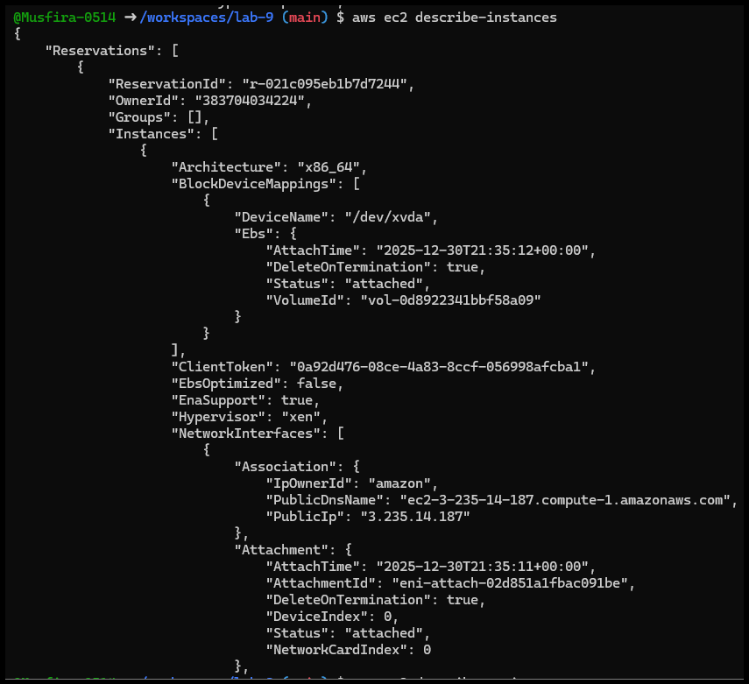
- aws ec2 describe-regions
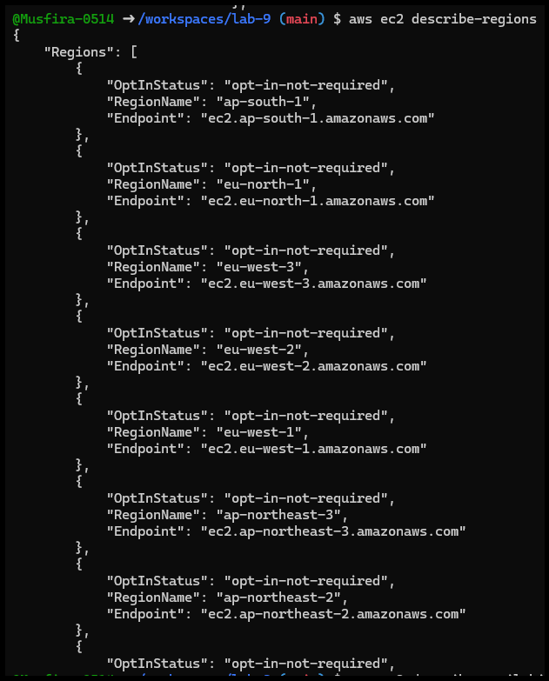
- aws ec2 describe-availability-zones
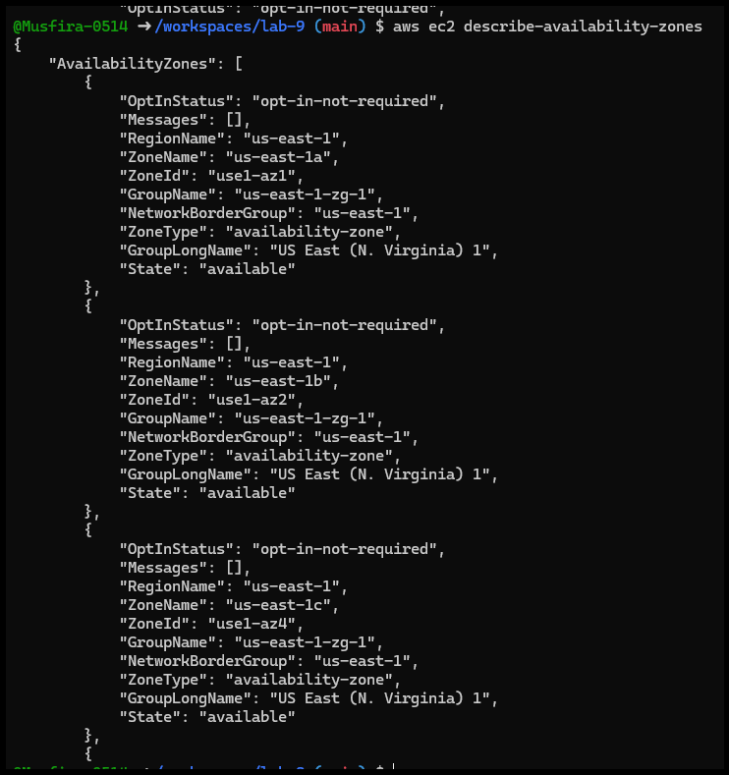
Task 6 — IAM: Group, User, Policies, Keys
Objective: Create IAM users/groups, attach policies, and configure keys.
- Create group & user
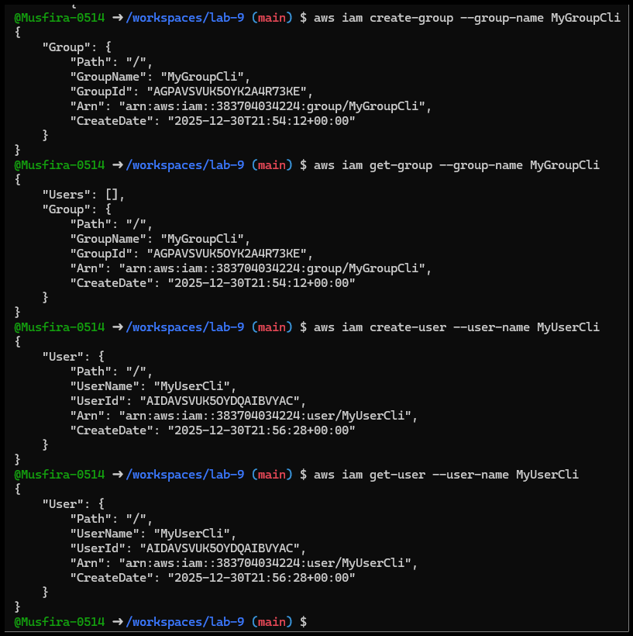
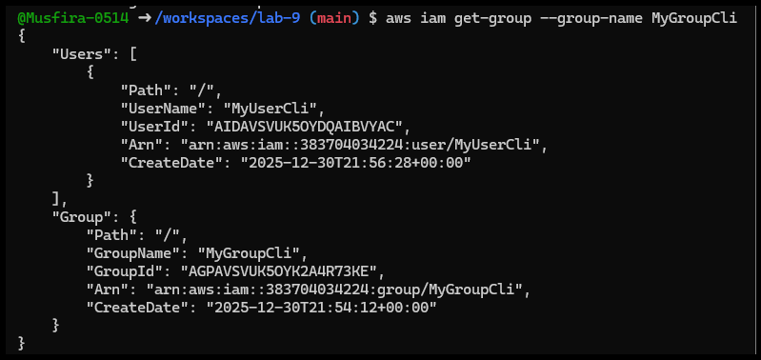
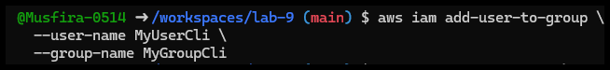
- Attach policy to group
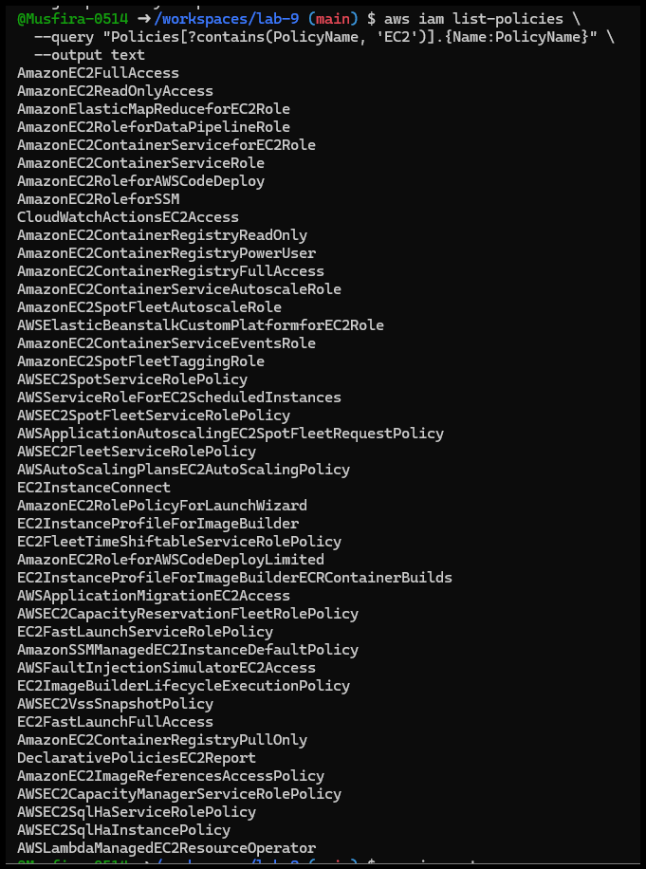
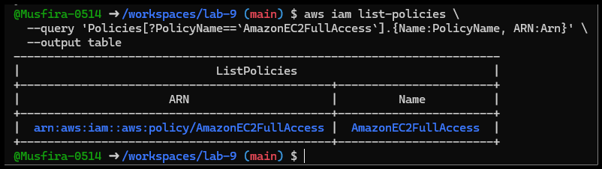
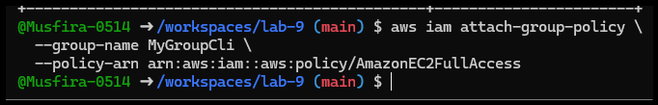
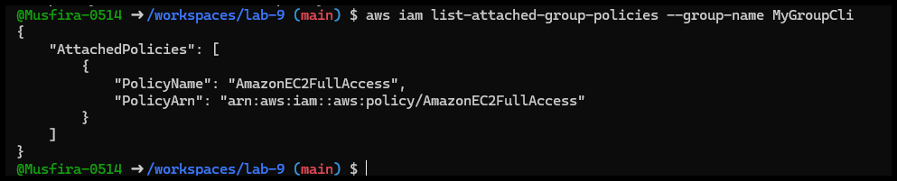
- Create login profile
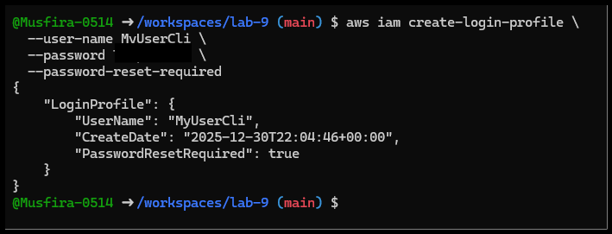
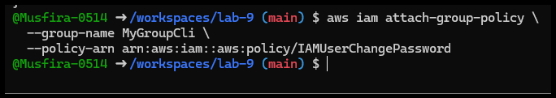
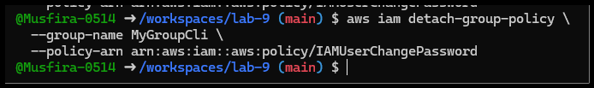
- Create access key

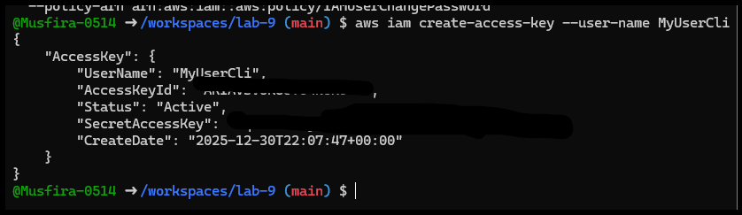
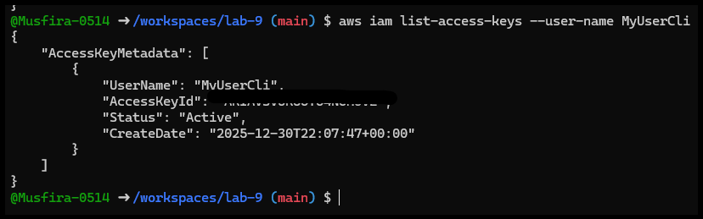
- Test environment variable authentication
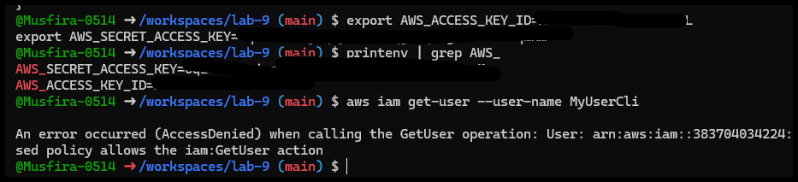
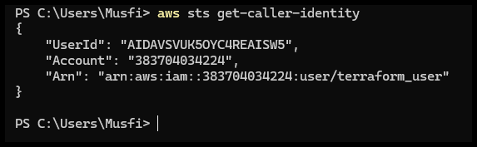

Task 7 — Filters: Describe-instances with filters
- Filter by Tag
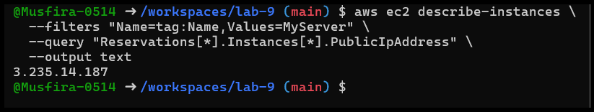
- Filter by Instance type
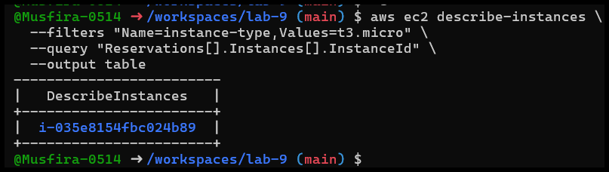
- Filter by Subnet
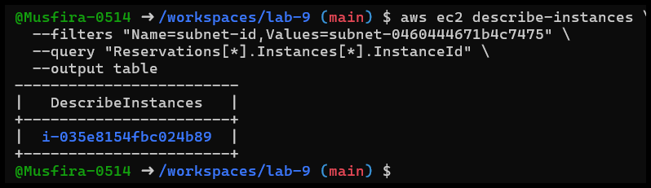
- Filter by VPC
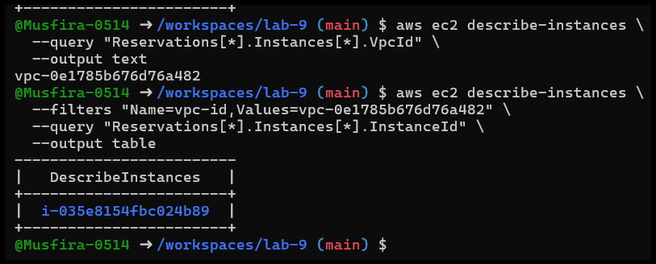
Task 8 — Query outputs formatted for reporting
- Instances with Name & IP
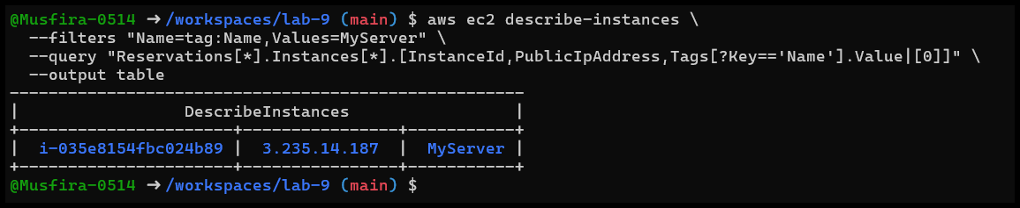
- Instance ID & State
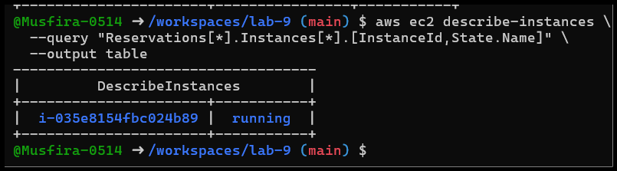
- Instance Type & AZ
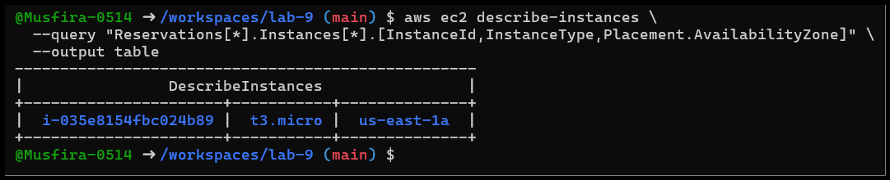
Cleanup — Remove AWS resources
- Terminate instances
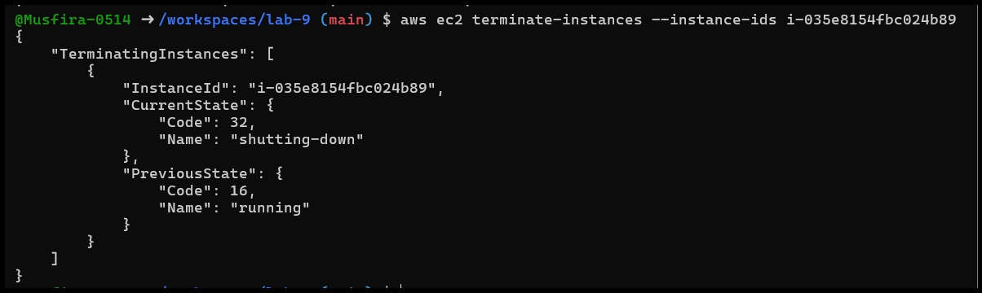
- Delete volumes/snapshots
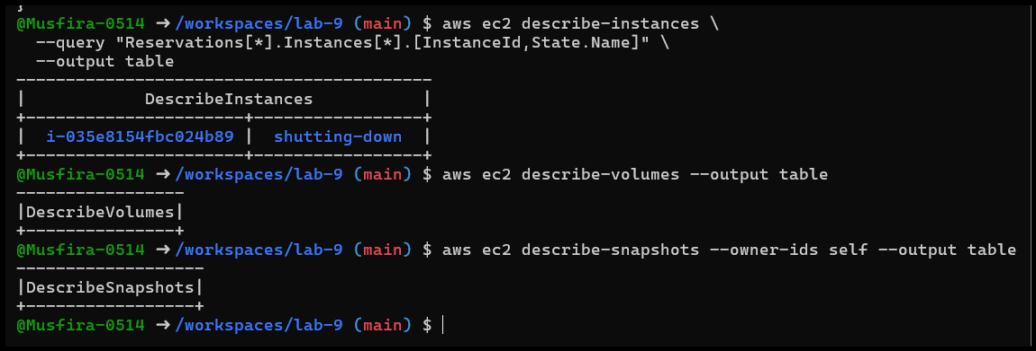
- Delete SG & key pair
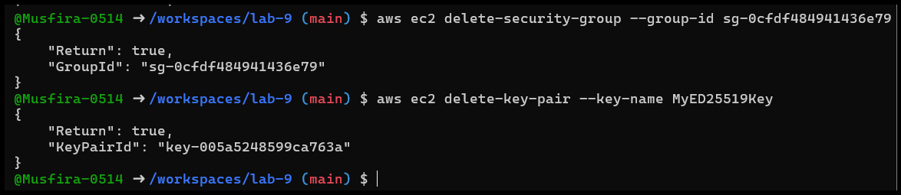
- Delete IAM users & groups
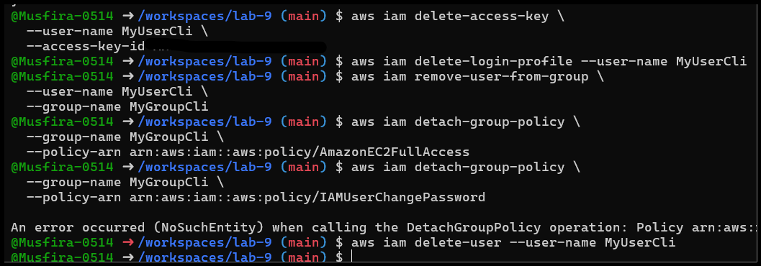
- Final verification
